NETWORKING 2

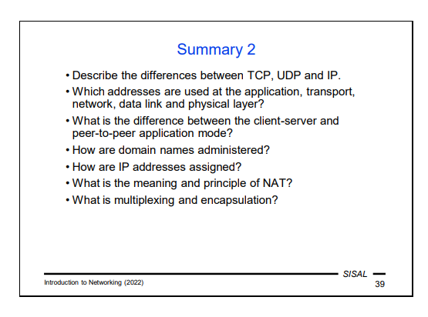

TCP UDP – protocols used on the transport layer, IP - used on the network layer of the TCP/IP stack. The difference between TCP and UDP is that TCP is connection oriented, a reliable protocol used on the transport layer that ensures successful transmission of data packets in order, while UDP is a connectionless protocol that does not guarantee nor order nor successfulness of data delivery, leaving the job of this handling to the application. IP is responsible for routing and addressing packets across networks. It is also not reliable in terms of transmission of packets, it simply routes packets based on their destination address, operating independently from TCP and UDP.
---------------TCP (Transmission Control Protocol), UDP (User Datagram Protocol), and IP (Internet Protocol) serve different roles in network communication. Here are the key differences:
Protocol Type:
TCP: Connection-oriented protocol. It establishes a connection before transmitting data and ensures reliability by guaranteeing the order of packets and retransmitting lost packets.
UDP: Connectionless protocol. It does not establish a connection before sending data, and there is no guarantee of packet delivery, order, or error recovery.
IP: A network layer protocol that is responsible for addressing and routing packets across networks. It operates independently of the transmission methods used by TCP and UDP.
Reliability:
TCP: Provides reliable data transfer with error checking, acknowledgments, and retransmission of lost packets.
UDP: Does not provide reliability. There are no guarantees that packets will arrive at their destination, or that they will arrive in the order they were sent.
IP: Does not guarantee delivery or reliability either. It simply routes packets based on their destination addresses.
Data Flow:
TCP: Operates with a byte stream; it breaks data into segments and ensures they are delivered in sequence.
UDP: Sends messages called datagrams, which may arrive in any order and may be duplicated or lost.
IP: Handles packets, routing them from the source to the destination without concern for the state of connection or order.
Overhead:
TCP: Has higher overhead due to its connection management, error checking, and flow control mechanisms.
UDP: Has lower overhead since it does not establish a connection and lacks error recovery mechanisms.
IP: Also has some overhead for addressing and routing, but this is separate from the transport layer protocols.
Use Cases:
TCP: Suitable for applications where reliability is crucial, such as web browsing (HTTP/HTTPS), file transfers (FTP), and email (SMTP).
UDP: Suitable for applications where speed is more critical than reliability, such as online gaming, video streaming, and voice over IP (VoIP).
IP: Fundamental for all internet communications as it defines how packets are addressed and routed.
These distinctions are crucial for understanding how data is transmitted over networks and the choice of protocol based on application requirements

The physical layer does not use any specific addresses as it is responsibl ofr the transmission of the actual bit stream. The data link uses MAC addresses, the network layer uses IP addresses and the application link uses domain addresses.
-------- Every address has a prefix defining a network to which the address belongs. The assignment of these network addresses, or address blocks, must meet certain conditions:
• Blocks of addresses that should be able to communicate directly with the rest of the world, so-called public addresses, are assigned to the network administrator by an ISP (or other authority) that connects the network to the Internet.
• For internal use, a network administrator may choose to use one or more private address blocks. They are inaccessible from the Internet (which increases security but complicates interoperability) and in order to enable hosts to access resources on the Internet, a router at the perimeter of the local network must use Network Address Translation (NAT).

The difference between server-client and P2P model is that the server-client has clearly defined roles for communication, the client send requests and the server mediates responses, while the P2P application mode does not have clearly defined roles, a computer searches for any others on the network to respond to its rewuests, while also providing data for all computers that sent requests, P2P is not very popular as it can illegaly distribute data.

How are domain names administered?
Domain names are administered through a hierarchical structure managed by various organizations. The top-level domains (TLDs) are administered by ICANN (the Internet Corporation for Assigned Names and Numbers). This includes technical domains (like arpa), categories (such as com, org, edu, mil, gov), country codes (like cz, sk), and even internationalized domain names. Second-level domains (SLDs) and lower-level domains are administered by their respective owners, allowing for flexibility in naming conventions according to organizational structures.

How are IP addresses assigned?
The IP has a prefix, so-called network address. Public ones are assigned to the network administrator by an ISP or some other authority and private ones are for internal use, the network administartor might choose to use one or more private addresses, inaccesssible from the internet.
------------A method of assigning addresses to hosts must be chosen by the network administrator and all hosts must follow these rules. The assignment can be static (each node has a predefined IP address) or dynamic (an address is assigned on demand), free (any host can join) or restricted (hosts must authenticate to connect). These rules apply even for private addresses. The only exception is so-called link-
local addresses –they are freely chosen by the host software (with a risk of duplicate address collisions) and they allow communication only within a directly connected network (and only if some other hosts also use a link-local address).
Assignment:
– central: IANA (Internet Assigned Numbers Authority),
department of ICANN
– regions: RIR (5x, Europe: RIPE NCC)
– further: ISP
– local network: network management (manually/automatically)

What is the meaning and principle of NAT?
NAT = Network Address Translation or IP masquerading. Its principle is to establish communication from external hosts to private networks. The router translates private sockets to external ones and vice-versa by modifying the contents of packets or from destaination ports.
--------Its principle is that when a host establishes a connection to a server, the router at the perimeter of the private network modifies the content of the packet so that the external host can respond. Translates private addresses from private networks to public ones for outside traffic.
The router has an external address and port for translation.
---------It involves a local network using private addresses for its internal traffic while translating them to public addresses for external communications.

What are multiplexing and encapsulation?
Multiplexing is a technique that means that several communication channels at one layer use the same communication channel at the underlying layer.
--------is a technique used to combine multiple signals or data streams into a single medium or channel. It allows efficient use of resources such as bandwidth by sending multiple data transmissions over a single communication link.
Encapsulation is a fundamental concept where data is wrapped with protocol information at each layer of a communication model.
--------- Layer n-1 takes the control information, processes it and then prepares a PDU according to the particular protocol of that layer. This PDU usually contains a body containing PDUn plus a header with control information. We call this method the encapsulation of the layer n data into the data at layer n-1.
- Port ... 16bit integer identifying one end of the communication channel - an application, or a process responsible for incoming data processing – destination-portmust be known by clients, usually it is one of so-called well-known services (formerly < 1024) – source-port is assigned by the originator's OS from unused port numbers (generic port)
- Socket ... one end of the communication channel between the client and the server … identification (“address”) of the channel end <IP address, port>

------------From a mathematical point of view, the unique identification of a TCP/IP connection is an ordered quintuple <source IP address, source port, destination IP address, destination port, transport layer protocol type>. This fact has two consequences:
- Two different application channels between two computers must differ at least in the source port.
- The same port numbers can be used for two different communication channels as long as they do not use the same transport layer protocol.

